Router 1 (192.168.48.254/24)
Router 2
(lan addr 172.16.1.1/24)
(wan addr 192.168.48.60/24)

Local MCS server (172.16.1.11/24
PC (192.168.48.90/24

Router 1 ‘s Lan port connects to Router 2 ‘s Wan port.
Step 1: On router 2, config ‘s like below to port forward.
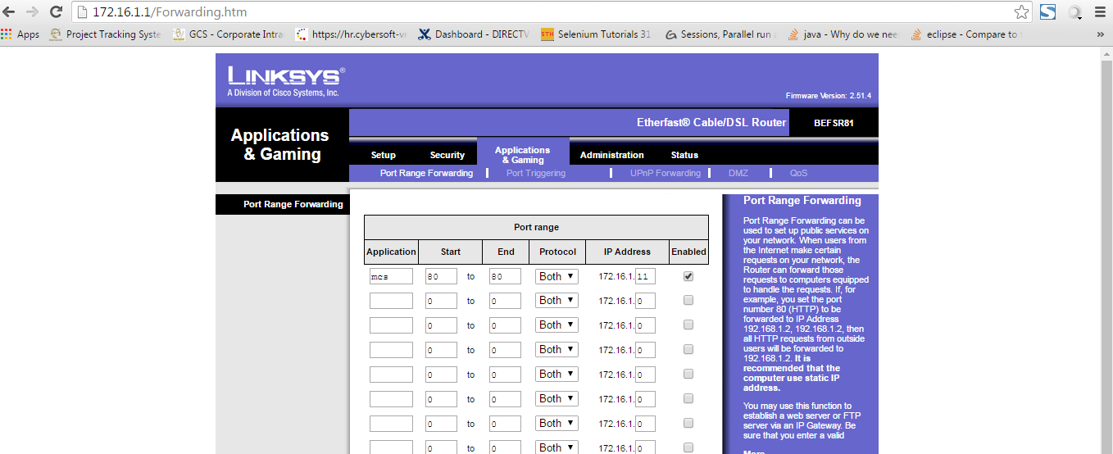
Step 2:
On pc, access 192.168.48.60:80 to access http:// 172.16.1.11/sbbmgr/login

